Analyzing UDP datagrams using Wireshark:

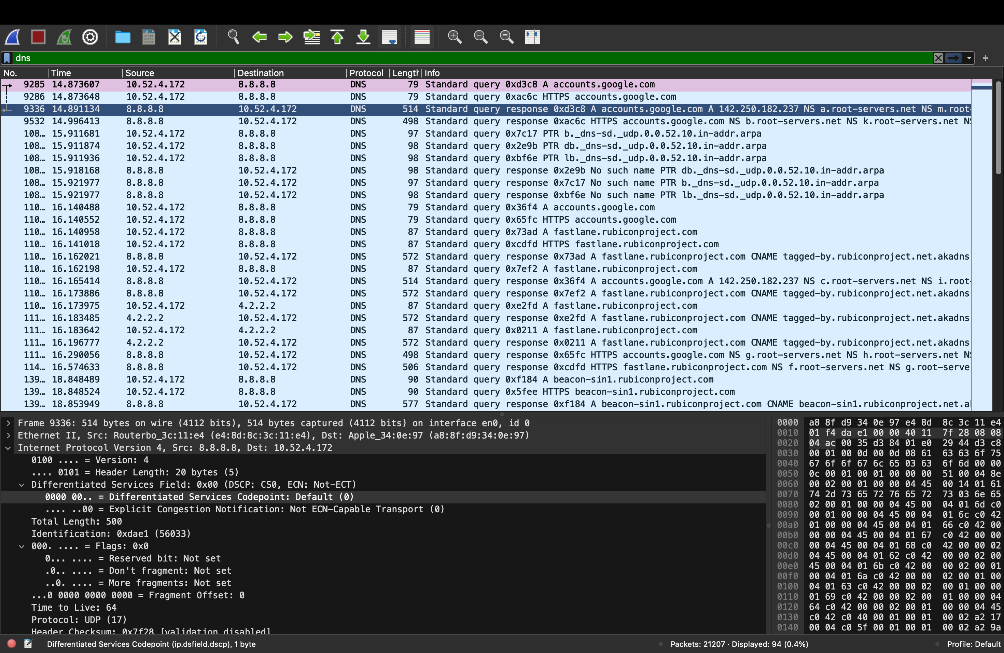

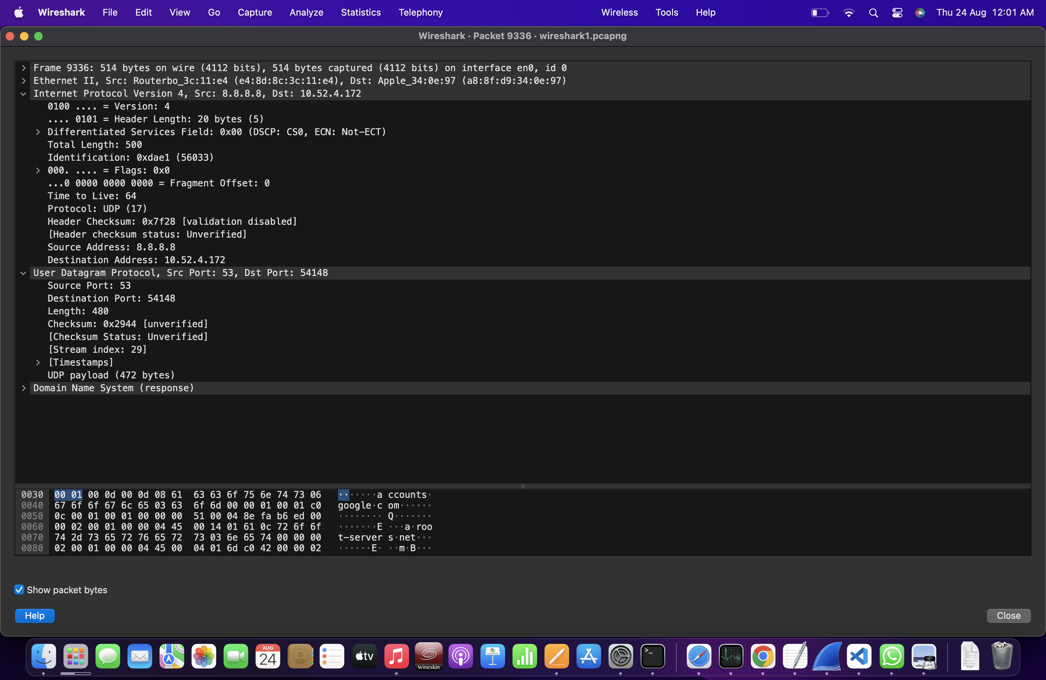

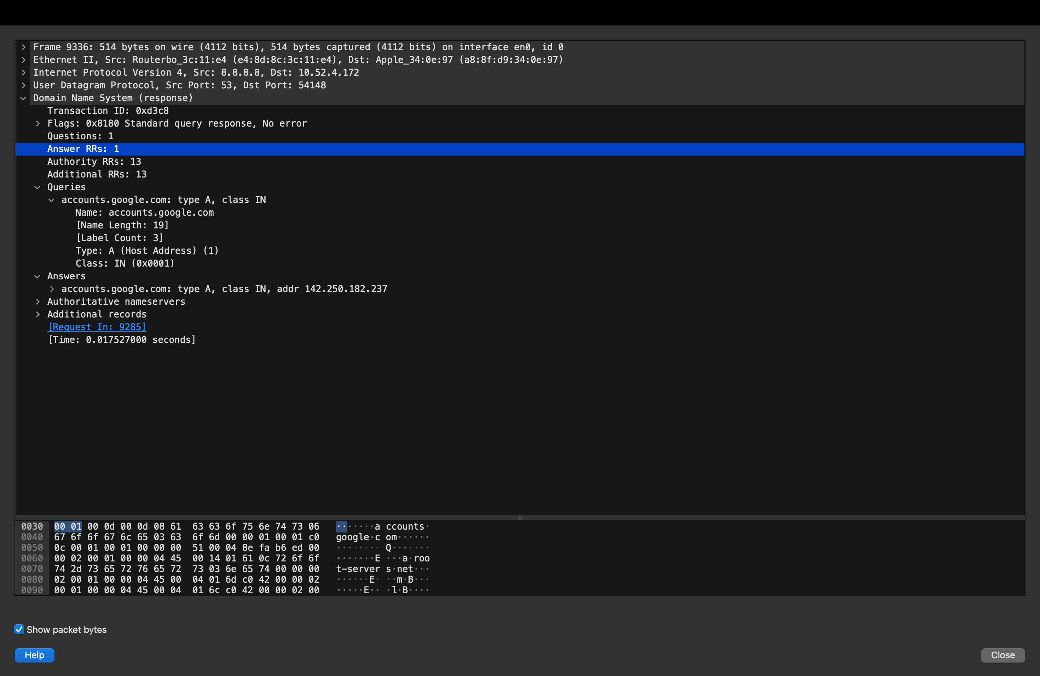

Analyzing TCP data packets using Wireshark:

1. Connection-Establishment Phase

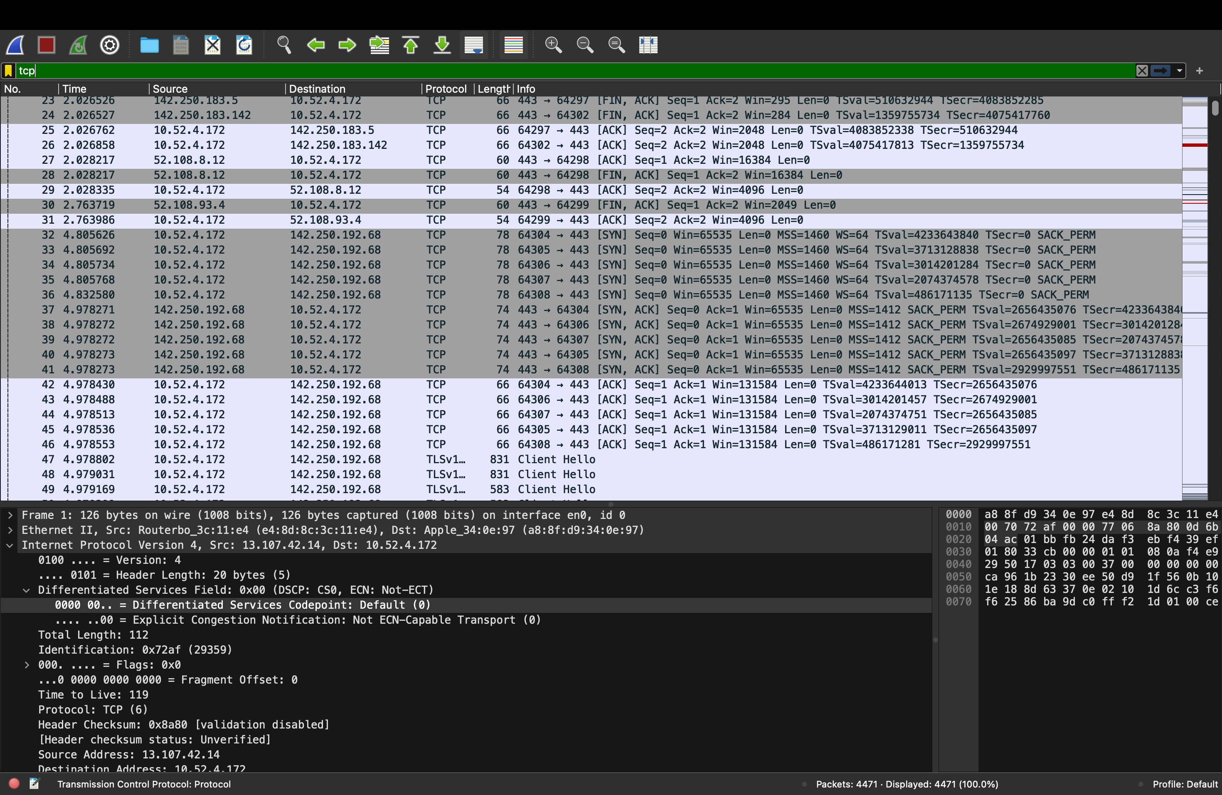

1. Data-Transfer Phase

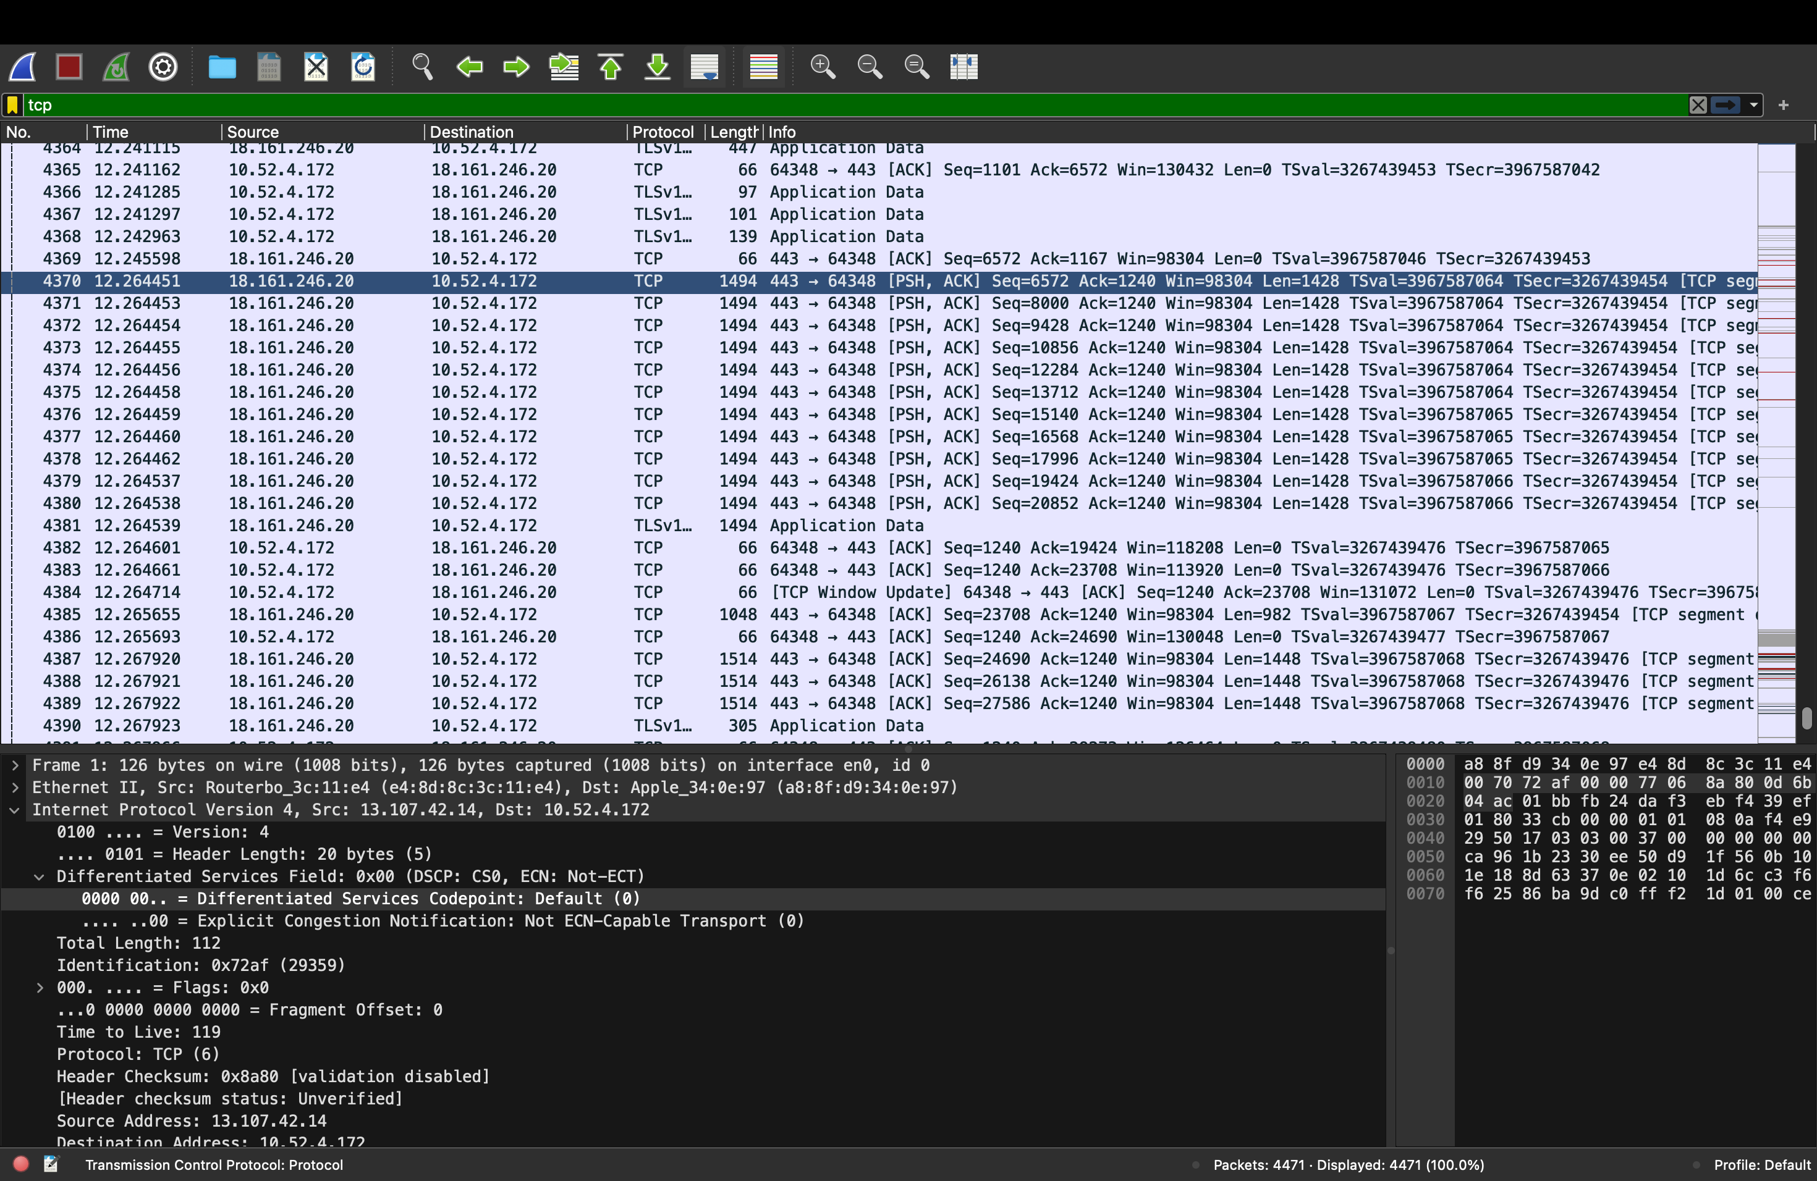

1. Connection-Termination Phase

